Business Requirement Document

# JOB LIFE CYCLE – Dispatch Phase

Sanjel Energy Services provide primary cementing and remedial well service for energy companies. Dispatcher manages resources to assure job execution and monitors job progress through whole job life cycle.

Following stages describe job activities during dispatch phase.

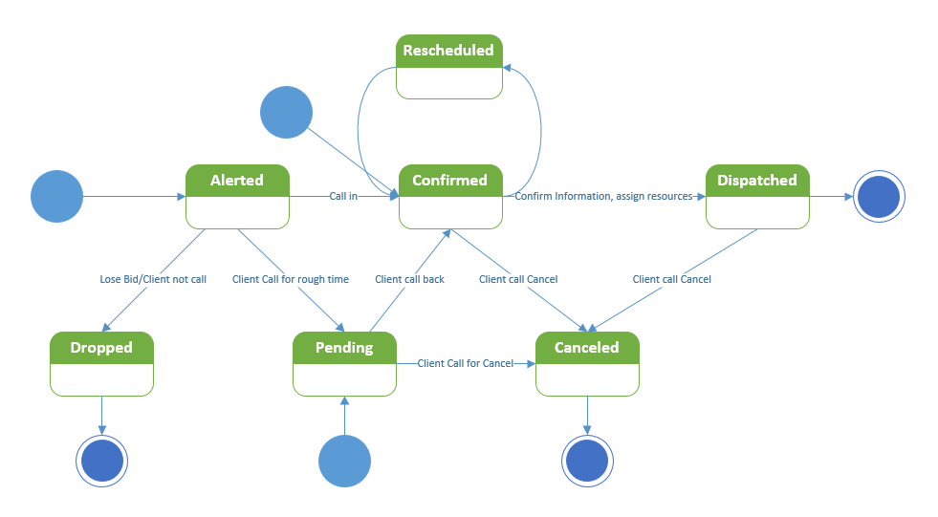

Job Alerted

Pre-condition: N/A

Role: Dispatcher

Scenario1: Dispatcher takes a call from Client Solution or Client Representative for a possible job(s) .

Criteria:

Required Information: Client Name, Well Location (may only be area level), Estimated Start Date, number of wells, Job Types, Rig Number (optional), Program Number(optional)

Post-condition: RigJob is created in Alerted status.

Comments: We don’t preschedule resources for jobs in Alerted status. An alerted job may be a multi-well job.

Job Pending

Precondition: Alerted Job exists or N/A

Role: Dispatcher

Scenario1: Client Representative calls Dispatcher to request a job execution, inform Location, Expected Time On Location and detail job information. Dispatch write down notes, and then create a call sheet.

Criteria:

Required Information: Client Name, Expected Time On Location, Well Location, Rig Information, Will Call Back Date Time, Direction to location, Safety Hazard and Special Instruction, Program Number(Optional)

Status Flags: Expected Time On Location is checked, Will Call Back Time is checked.

Status flag should be “Expected on location time” checked only. “Will call back” time is optional.

Postcondition: A call sheet is created. Resource prescheduling process is started.

Comments: All scheduled resources are in pre-scheduling status, not firm.

Job Confirmed

Precondition: Pending or alerted Job exists or N/A

Role: Dispatcher

Scenario1: Client representative calls (back) Dispatcher to confirm a job requested on location Datetime and other detail information if needed.

Criteria:

Required Information: Client Name, Call Out Requested Date/Time, Program Number(Optional)

Status Flags: Expected Time On Location is unchecked, Requested Date/Time is entered.

The difference between job confirmed and scheduled, when Job Confirmed call sheet is in progress.

Job Scheduled (Ready)

Precondition: Confirmed Job exists

Role: Dispatcher

Scenario1: Dispatcher to double check call sheet with program, assign resources.

Criteria:

Required Information: Program Number

Status Flags: All mandatory information have been entered.

Call sheet is locked by supervisor

Comments: All resources schedules are firm, no conflict with other schedule.

Job Dispatched (Called out)

Job Dropped

Precondition: Job is alerted

Role: Dispatcher

Scenario1: Client Solution notify the job is dropped with an reason

Scenario2: Client Representative notify the job is not going to happen

Scenario3: Job is over the preset estimate start date for XX days, Dispatcher check with client solution or Client Representative

Job Canceled

Precondition: Any time from pending until job operation is started.

Role: Dispatcher

Scenario: Client Representative calls Dispatcher to cancel a job that under dispatch process.

# RIG STATUS

Dispatchers are tracking the Rigs assigned to Sanjel customer to conduct job scheduling, the rig status indicates the potential job occurrences.

Status 1 – Active

Rig is actively drilling or in service. For Sanjel dispatcher consideration, there are there statuses related to the job status.

Adam, the below “rig statuses” are covered by the job statuses in the previous section.

Pending – There are jobs pending on the rig.

In Progress – There is a job working on the rig.

Complete - The job working on the rig has been completed.

I suggest that we maintain the current method of tracking rig statuses:

Status 1 – Rig is active and is counted towards Sanjel’s total rig count and market share.

Status 2 – Rig is currently down but we are still monitoring for upcoming work:

* Down for maintenance
* Rig is done but still have our equipment (bin) in their possession
* Rig is down for weather,
* Rig is waiting for new lease and or licenses.

Status 3 does not need to be used, if a rig is complete then it can just be removed from the board. Or we can use status 3 to hide rigs for re-activation at a later date.

Status 2 – Down

Rig doesn’t have business with Sanjel for any reasons. This reflects old OPS Tracker status 2 and 3, but ignore the reason description in status 2. Not correct see above

# JOB FACTORS

Following concepts are commonly understood well, will put in description later.

Company

LSD

Rig

Job Type

Job Date

Blends

Tools - later phase

Crew - Later phase

Bin

Special Instructions

Safety Hazards

Are these job factors indended to be on the rig board or do you intend to still work within eService to manipulate these ie hazards/tools/special instructions?

# Workflow

Basically, we are not significantly change current dispatch process, we are creating a tool to facilitate dispatcher to be more efficient and accurate.

More details To Be Continued.